**Introduction:**

This Documentationoutlines the core concepts of each model, highlights their implementation steps, and presents a detailed evaluation. In this project, three deep learning architectures *ResNet*, *DenseNet*, and *Xception* were implemented and evaluated for their ability to classify weather conditions accurately. Each model represents a Specific approach to tackling the challenges of deep learning, such as vanishing gradients, computational efficiency, and scalability.

**Xception Model :**  
The Xception model short for *"Extreme Inception"*, proposed by François Chollet, is an evolution of Inception architectures that replaces Inception modules with **depthwise separable convolutions**, leading to better parameter efficiency and performance.

**Core Concept: Depthwise Separable Convolutions**

* **Standard Convolution**: Simultaneously maps spatial and channel-wise correlations.
* **Depthwise Separable Convolution**: Decouples spatial and channel-wise correlations into two steps:
  1. **Depthwise Convolution**: Applies a spatial convolution independently on each channel.
  2. **Pointwise Convolution**: Uses a 1x1 convolution to combine the outputs across channels.

This decoupling reduces computational cost while maintaining accuracy.

**Xception's High-Level Structure:**

Xception consists of three main parts:

1. **Entry Flow**
2. **Middle Flow**
3. **Exit Flow**

Each part contains multiple convolutional layers, depthwise separable convolutions, and residual connections.

**Entry Flow**

The Entry Flow extracts low-level features and progressively reduces spatial dimensions while increasing depth (number of filters).

**Key components:**

1. **Convolution Layers**: Extract low-level features (e.g., edges).
2. **Depthwise Separable Convolutions**: Decouple spatial and channel-wise learning.
3. **Residual Connections**: Add the input back to the output, preserving feature information.

* **Steps**:
  1. **Initial Convolution**:
     + A 3x3 convolution with stride 2 followed by batch normalization and ReLU activation.
     + Reduces spatial size while increasing the feature depth.
  2. **Three Blocks with Depthwise Separable Convolutions**:
     + Each block has:
       - Depthwise separable convolutions.
       - Batch normalization and ReLU.
     + A shortcut connection is applied (residual connection) to add the input to the output of the block.
  3. After this phase, the spatial dimensions are significantly reduced, and the model starts focusing on higher-level features.

**Middle Flow:**

The Middle Flow is the core of Xception, where the model performs most of its computation. It focuses on learning abstract features through repeated depthwise separable convolutions.

**Steps:**

* 1. **Eight Identical Blocks:**
     + **Each block contains:**
       - Depthwise separable convolutions (3x3).
       - Pointwise convolutions (1x1).
       - Batch normalization and ReLU.
     + *No spatial reduction happens here; the dimensions remain constant while enriching feature representations.*
  2. **Residual Connections:**
     + These connections help preserve the flow of gradients, making the network easier to train.

**Exit Flow:**

Finalizes feature extraction and prepares for classification.

* **Steps**:
  1. **Depthwise Separable Convolutions**:
     + Similar to Entry Flow, but with more filters to capture complex patterns.
     + Includes pointwise convolutions.
  2. **Global Average Pooling (GAP)**:
     + Reduces each feature map to a single value by averaging spatial dimensions.
     + This reduces the number of parameters and prevents overfitting.
  3. **Fully Connected (Dense) Layer**:
     + A final dense layer is used for classification (e.g., predicting sunny, rainy, or stormy weather).
  4. **Softmax Activation**:
     + Produces probabilities for each class.

**Steps of xception model :**

**1-Loading and Preprocessing the Data**

**2- Dataset Path and Normalization**

* The dataset for training and evaluation is loaded from the specified directory. Images are resized to 224x224 pixels, and the pixel values are normalized by scaling them between 0 and 1 using a rescaling layer.

**3-Dataset Loading and Splitting**

* The dataset is loaded into TensorFlow and divided into training, validation, and test sets, with 70% allocated for training, 15% for validation, and 15% for testing.

**4-Normalization and Data Augmentation**

* Data augmentation techniques, such as random flips, rotations, zooms, and contrast changes, are applied to the training set. This helps to improve the model's generalization capability. Additionally, all datasets are normalized to prepare the images for the model.

**5-Prefetching Data**

* To enhance performance, the datasets are pre-fetched using AUTOTUNE, enabling faster data loading during training.

**Model Architecture:**

**Base Model: Xception**

* The Xception model, pre-trained on ImageNet, is used as the base model. Its top layers are removed, and the remaining layers are leveraged to extract high-level features from the input images. The pre-trained weights of Xception are frozen during the initial training phase.

**Freezing Initial Layers**

* To retain the pre-trained weights, only the last layers of the Xception model are unfrozen for fine-tuning. The initial layers are kept frozen during the early training phase to avoid disrupting the learned weights.

**Custom Layers**

The model includes custom layers on top of the base Xception model:

* **Global Average Pooling Layer:** This layer pools the output from the Xception model to produce a fixed-length feature vector.
* **Dense Layers:** Two dense layers with ReLU activation and dropout regularization are added to learn specific features of the weather data.
* **Output Layer:** The final output layer uses a softmax activation function to classify the input image into one of the weather categories.

**Model Compilation**

* The model is compiled using the Adam optimizer with a small learning rate, suitable for fine-tuning pre-trained models. The loss function used is sparse categorical cross-entropy, appropriate for multi-class classification tasks.

**4. Training the Model**

**Initial Training**

* The model is initially trained for a set number of epochs with the base model's layers frozen. This allows the model to adapt the weights for the weather classification task while retaining the useful pre-trained features.

**Fine-Tuning the Model**

* After the initial training, the deeper layers of the Xception model are unfrozen for fine-tuning. A smaller learning rate is used during this phase to refine the model's weights without overfitting.

**Saving the Model**

* Once the model is trained, it is saved for later use or further evaluation.

**5. Model Evaluation**

**Test Accuracy**

* The model is evaluated on the test dataset to calculate its accuracy. This gives an indication of how well the model generalizes to new, unseen data.

**Predictions and Classification Metrics**

* Predictions are made on the test data, and a classification report is generated to show key metrics such as precision, recall, and F1-score for each class.

**Confusion Matrix**

* A confusion matrix is used to visualize the model's performance on the test set, displaying the number of correct and incorrect predictions across each class.

**ROC and AUC**

* The Receiver Operating Characteristic (ROC) curve is plotted for each class to evaluate the model's ability to distinguish between classes. The Area Under the Curve (AUC) is calculated to assess the overall performance.

**Plotting Accuracy and Loss**

* The accuracy and loss over epochs are plotted to visualize the model's learning progress during both the initial training and fine-tuning phases.

**Pros and Cons of Xception Model:**

**Pros:**

1. **Efficiency**:
   * Uses fewer parameters and computations due to depthwise separable convolutions.
   * Easier to train compared to architectures with standard convolutions.
2. **Performance**:
   * Outperforms Inception V3 in image classification tasks like ImageNet.
   * Better utilization of model parameters.
3. **Flexibility**:
   * Suitable for transfer learning and tasks with varying datasets.
   * Residual connections aid in convergence and avoid vanishing gradients.
   * Performs well with transfer learning by using pre-trained weights on large datasets like ImageNet.
4. **Expressiveness**:
   * Focuses on independent channel-wise and spatial feature learning, improving representational power.

**Cons:**

1. **Complexity in Understanding**:
   * The decoupling of spatial and channel-wise correlations can be challenging to conceptualize.
2. **Training Time**:
   * Slightly slower training compared to simpler architectures.
3. **Resource Requirements**:
   * Requires efficient hardware for faster depthwise convolution operations.

**DenseNet Model:**

DenseNet (***Densely Connected Convolutional Network***) is an innovative architecture aimed at improving information flow and reducing redundancy in deep neural networks through the network by establishing dense connections between layers. Each layer receives feature maps from all preceding layers and passes its feature maps to all subsequent layers, making the network highly efficient in utilizing parameters.

**Key Components of DenseNet:**

1. **Dense Block**:
   * A dense block is a sequence of convolutional layers where every layer is connected to every other layer.
   * For a block with L layers, each layer has L(L+1)/2 direct connections.
   * Each layer within a dense block receives inputs from all preceding layers and passes its outputs to all subsequent layers within the same block.
   * The connection pattern ensures maximum feature reuse and efficient gradient flow.

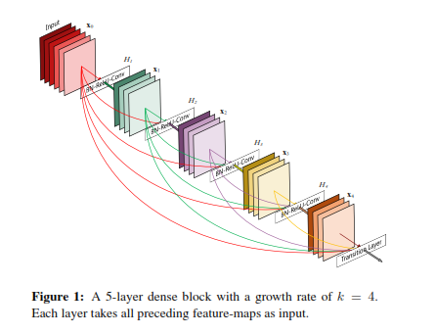

1. **Transition Layers**:
   * Transition layers are positioned between dense blocks to reduce the size of feature maps and prevent the network from growing too large and improve computational efficiency.
   * They consist of:
     + **1x1 Convolution**: Reduces the number of feature maps.
     + **2x2 Average Pooling**: Reduces spatial dimensions.

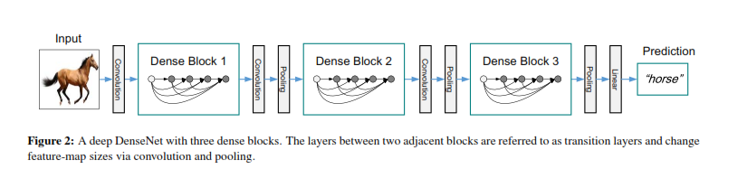

1. **Growth Rate**:
   * Determines the number of feature maps added by each layer.
   * A small growth rate leads to a compact model, while a larger growth rate increases capacity.

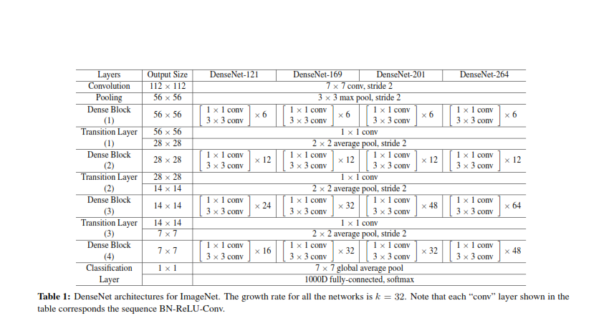

1. **Global Average Pooling and Classification**:
   * At the end of the network, global average pooling reduces the spatial dimensions to a single value per feature map, followed by a fully connected layer for classification.

**Steps of the Model:**

**1. Dataset Preparation**

* Dataset Path: The dataset is located at dataset_path, which is where the weather images are stored.
* Normalization: The images are normalized by rescaling pixel values to the range [0, 1] using layers.Rescaling(1.0 / 255).
* Loading Data: The images are loaded into TensorFlow using image_dataset_from_directory. This function automatically labels images based on the directory structure.
* Splitting Dataset: The dataset is split into training (70%), validation (15%), and testing (15%) sets using take() and skip() functions**.**

**2. Data Augmentation**

* Data Augmentation: A sequence of random transformations is applied to the training data (random flip, rotation, zoom, contrast adjustment) to improve generalization by artificially increasing the dataset size.

**3. DenseNet Base Model**

* Pre-trained DenseNet121: The code loads a pre-trained DenseNet121 model, which is trained on ImageNet. The include_top=False argument means that the final classification layer is excluded since we will add our own custom layers later.
* Custom Layers: The code adds custom layers to the base model:
* GlobalAveragePooling2D to reduce spatial dimensions.
* A dense layer with 256 neurons and ReLU activation for feature learning.
* The final softmax layer is added to output probabilities for each class in the dataset.
* Freezing Base Model: Initially, the layers of DenseNet121 are frozen (trainable=False) to prevent their weights from being updated during the first phase of training.

**4. Training the Model**

* The model is compiled using Adam optimizer and sparse categorical crossentropy loss function, appropriate for multi-class classification problems. The training begins with frozen layers in the base model.
* The model is trained for 10 epochs, with validation on the validation dataset at each epoch to monitor performance.

**5. Fine-Tuning**

* Unfreezing Layers: After the initial training, some deeper layers of DenseNet121 are unfrozen (the last 50 layers in this case). Fine-tuning these layers allows the model to adapt better to the specific characteristics of the weather dataset.
* Lower Learning Rate: The learning rate is reduced (using learning_rate=1e-5) to prevent catastrophic forgetting of pre-learned features from ImageNet during fine-tuning. Fine-tuning is done for 5 epochs, a shorter duration compared to initial training.

**6. Evaluate the Model**

* The model is evaluated on the test set to check its final performance after fine-tuning.

**7. Classification Report and Confusion Matrix**

* The predictions of the model on the test dataset are compared to the true labels, and a classification report is generated. This report includes metrics like precision, recall, and F1-score for each class.
* A confusion matrix is plotted to visualize how well the model is performing in terms of classifying each class correctly.

**8. ROC and AUC**

* ROC Curve: The model's performance for each class is evaluated using Receiver Operating Characteristic (ROC) curves. The area under the ROC curve (AUC) is calculated and plotted. This is useful for binary classification problems, but in a multi-class setting, it's plotted for each class individually.

**9. Training History Visualization**

* Accuracy and Loss: The training and validation accuracy and loss are plotted across epochs for both the initial training and fine-tuning phases. This helps visualize how the model improves over time.

**Key Concepts in Fine-tuning:**

* Frozen Base Layers: Initially, the base DenseNet model is frozen to keep its weights intact and only train the custom layers.
* Fine-tuning: After initial training, certain layers of the pre-trained DenseNet model are unfrozen to adapt the pre-trained weights to the specific weather detection task. Fine-tuning with a smaller learning rate prevents overwriting the pre-trained knowledge.

**Pros and Cons of DenseNet Model:**

**Pros :**

1. **Efficient Feature Reuse:**
   * Layers directly access preceding outputs, preventing redundancy and enabling efficient use of parameters.
2. **Improved Gradient Flow:**
   * Dense connections alleviate the vanishing gradient problem, enabling training of very deep networks.
3. **Parameter Efficiency:**
   * Requires fewer parameters than comparable networks due to bottleneck and compression techniques.
4. **Reduced Overfitting:**
   * Implicit regularization reduces the risk of overfitting, especially on small datasets.
5. **Compact and Accurate:**
   * Models achieve state-of-the-art accuracy with fewer parameters and computations compared to ResNets.

**Cons:**

**High Memory Usage:**

* Dense connections increase memory requirements for storing intermediate feature maps.

**Longer Training Time:**

* Concatenating feature maps at every layer adds computational overhead.

**Scalability Issues:**

* The quadratic growth of connections makes DenseNet less scalable for extremely deep networks.

**ResNet Architecture :**

* **ResNet (Residual Networks)** introduced a novel deep learning framework to address the challenges associated with training very deep networks, particularly the degradation problem (where increasing depth beyond a certain point leads to increased training error) It introduced a novel approach called **residual learning**, which allows the model to learn identity mappings by adding "shortcut connections" between layers.

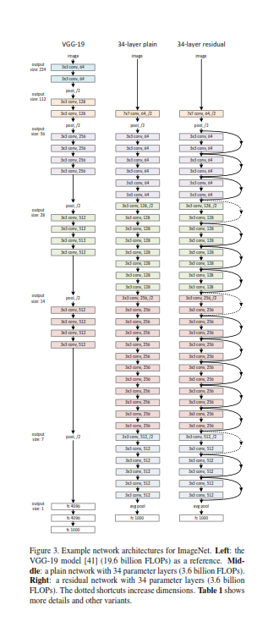

**Key Concepts**

1. **Residual Learning:**
   * Instead of directly learning the underlying mapping H(x), ResNet reformulates it as F(x) = H(x)− x.
   * This makes the original mapping H(x) = F(x)+x, simplifying the learning process.
   * If the identity mapping H(x) = x is optimal, the network only needs to drive the residual function F(x)to zero.
2. **Shortcut Connections:**
   * Identity shortcuts directly connect the input of a layer to its output.
   * These connections allow gradients to flow directly through the network, mitigating the vanishing gradient problem.
3. **Residual Block Configuration**

**The model stacks residual blocks as follows:**

* + - 2 blocks with 64 filters.
    - 2 blocks with 128 filters (stride=2 for the first block).
    - 2 blocks with 256 filters (stride=2 for the first block).
    - 2 blocks with 512 filters (stride=2 for the first block).

**Each residual block consists of:**

* Two convolutional layers with 3x3 filters.
* Batch normalization after each convolution.
* A ReLU activation after the first convolution.
* Identity skip connections, with optional downsampling for dimensionality matching.A diagram of a bottleneck and bottleneck diagram

  Description automatically generated

**Steps of the Model**

**1. Dataset Preparation:**

**Loading the Dataset**

* Images are loaded from a specified directory and resized to a uniform size of 224x224 pixels.
* The data is grouped into batches of 32 images for efficient processing.

**Splitting the Dataset**

* The dataset is divided into training, validation, and test sets.
* The training set is used for learning, the validation set for tuning, and the test set for final evaluation.

**Data Augmentation**

* To prevent overfitting, random transformations like flipping, rotating, and zooming are applied to training images.
* This increases the variety of data the model sees during training.

**Normalization**

* Pixel values are scaled to a range of 0 to 1 to stabilize and speed up the training process.

**Performance Optimization:**

* The data pipeline is optimized by prefetching batches, ensuring faster data loading during training.

**2. ResNet Architecture:**

**Initial Convolutional Block:**

* A large convolutional layer extracts initial features from the images.
* Batch normalization stabilizes the learning process.
* A ReLU activation introduces non-linearity.
* Max pooling reduces the spatial dimensions while retaining key features.

**Residual Blocks:**

* These are the core building blocks of ResNet, designed to learn the difference (residual) between the input and output features.
* Each block contains two convolutional layers, batch normalization, and a skip connection that adds the input back to the output. This helps the network train efficiently even when very deep.

**Downsampling:**

* In certain blocks, the spatial size of feature maps is reduced by adjusting the convolution stride.
* Skip connections are also adapted using additional layers to match the dimensions when downsampling occurs.

**Global Average Pooling:**

* The feature maps are reduced to a single value per map by averaging, which results in compact and meaningful features.

**Fully Connected Layer:**

* The final layer maps the features to class probabilities using a softmax activation function.

**3. Training the Model**

**Compilation:**

* The Adam optimizer is used for efficient parameter updates during training.
* A sparse categorical cross-entropy loss function measures the error for multi-class classification.
* Accuracy is tracked as the performance metric.

**Training Process:**

* The model is trained over several epochs, where it learns patterns from the training data and adjusts its weights.
* Early stopping halts training if no improvement is seen in validation loss for a set number of epochs.
* A learning rate scheduler reduces the learning rate when progress slows down, ensuring the model continues to improve.

**4. Evaluating the Model**

Once trained, the model is tested on unseen data.

**Pros and Cons**

**Pros**

1. **Customizability:** Full control over architecture design for specific tasks or datasets.
2. **Deep Understanding**: Enhances knowledge of deep learning concepts like residual blocks and optimization.
3. **Residual Connections:** Reduces vanishing gradient issues, enabling deeper and more effective networks.
4. **Efficient Training**: Easier optimization due to skip connections, even for very deep models.
5. **Domain-Specific Learning:** Learns features tailored to the dataset without relying on pretrained weights.
6. **Data Augmentation:** Improves generalization and robustness with augmentation techniques.

**Cons**

1. **No Pretrained Knowledge:** Slower convergence and lower initial accuracy compared to models with pretrained weights.
2. **Resource Intensive:** Requires significant computational power and time for training.
3. **Hyperparameter Sensitivity:** Needs careful tuning for optimal performance.
4. **Overfitting Risk:** Small datasets may lead to overfitting, even with residual connections.
5. **Implementation Complexity**: Challenging to debug and optimize due to intricate architecture design.

**Model Performance Comparison**

* 1. **DenseNet:**

**Test accuracy: 83.33%**

**Roc: Confusion Matrix:**

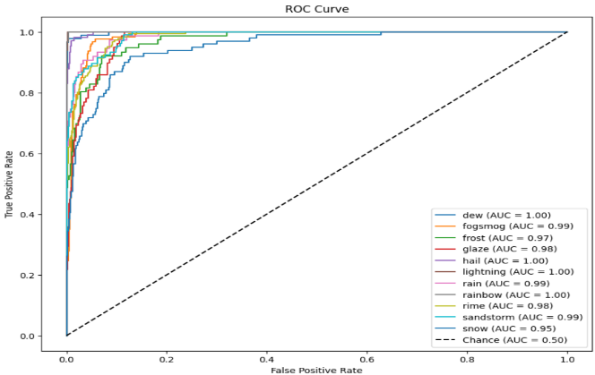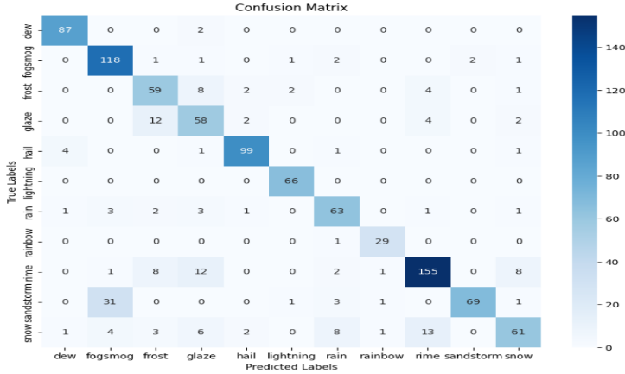

**Classification Report:**

**Accuracy over Epochs: Loss over Epochs:**

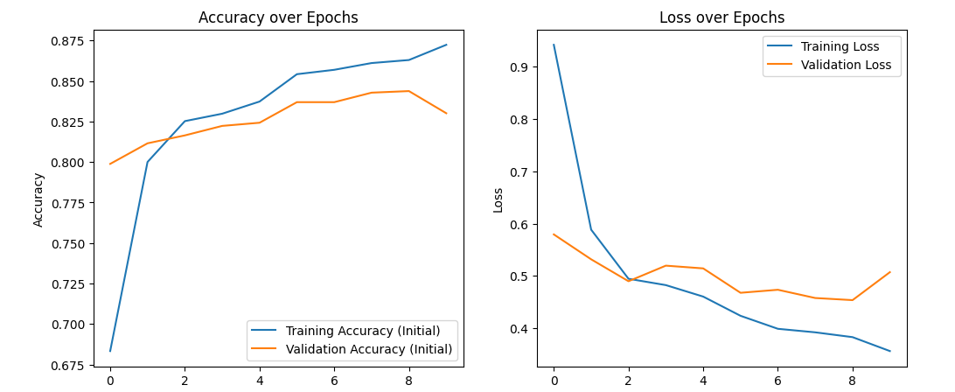

* 1. **Xception Model:**

**Test Accuarcy :** 89.50%

**Roc: Confusion Matrix:**

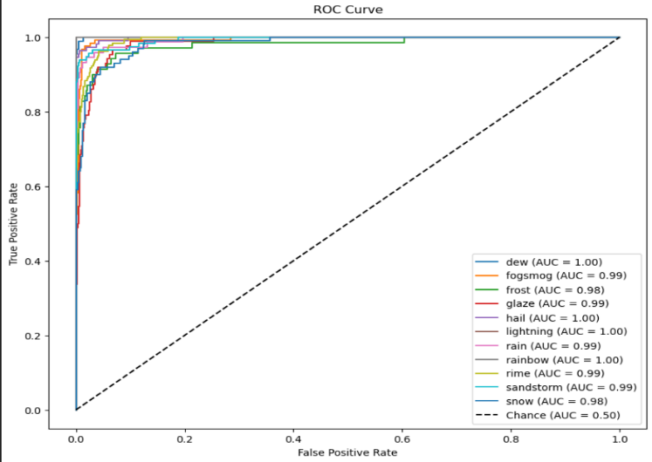

**Classification Report:**

**Training and Validation accuracy: Training and validation loss:**

* 1. **Resnet Model:**

**Test accuracy:** 71.00%

**Roc: Confusion Matrix:**

**Classification Report:**

**Training and Validation accuracy: Training and validation loss:**

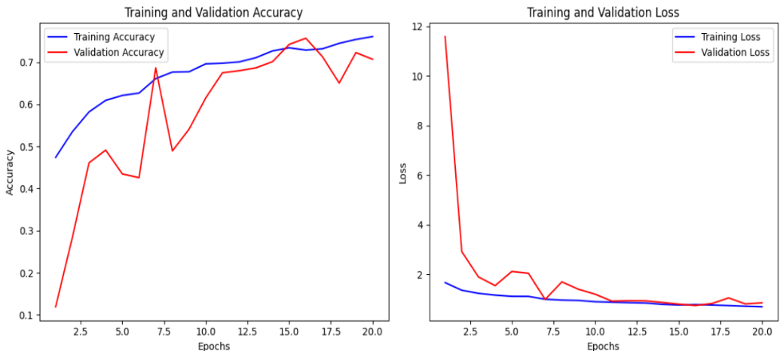

**Comparison and Insights**

* ***DenseNet*** achieved the highest accuracy (83.33%), demonstrating its strength in transfer learning with fine-tuned layers.
* ***Xception*** struck a balance between performance and computational efficiency, achieving an accuracy of( 89%).
* ***ResNet***, although the least accurate (71%), served as a foundational model with custom architecture, showcasing the impact of designing models from scratch

| **Model** | **Accuracy (%)** | **Advantages** | **Disadvantages** |
| --- | --- | --- | --- |
| **Xception** | **89%** | - High accuracy for the given dataset. - Efficient depthwise separable convolutions. | - Computationally intensive. - Requires a large amount of data for optimal performance. |
| **DenseNet** | **82%** | - Effective feature reuse through dense connections. - Reduces vanishing gradient issues. | - Increased memory requirements due to concatenated feature maps. - Slower inference speed. |
| **ResNet** | **71%** | - Simple and efficient residual connections. - Works well with relatively small datasets. | - Lower accuracy compared to the others. - May struggle with very deep architectures. |

**Conclusion**

Based on the analysis, **DenseNet** is the most effective model for the given task due to its superior accuracy. However, **Xception** offers a viable alternative with moderate accuracy and potentially lower computational requirements. **ResNet** highlights the trade-offs in implementing models from scratch and sets a baseline for further improvement.

**References :**

* <https://arxiv.org/abs/1512.03385>
* <https://arxiv.org/abs/1608.06993>
* <https://arxiv.org/abs/1610.02357>